Weather App text field can be edited but nothing happens when submit is “clicked”

Weather app Submit button “spinning” not enabled

Logs link in the left panel shows log page with no entries

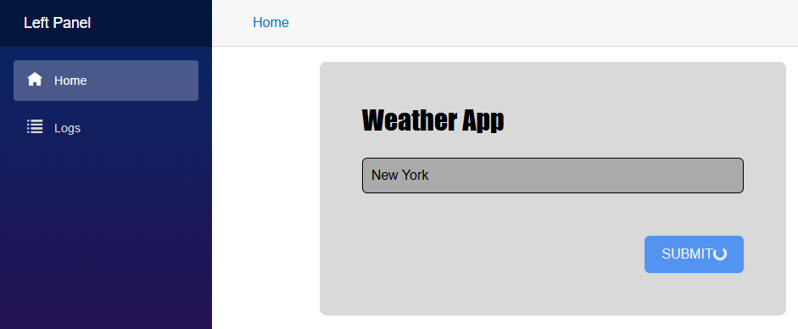

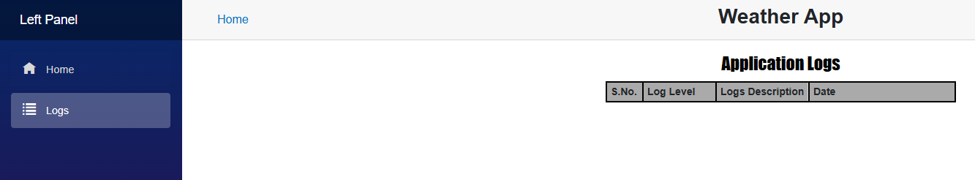

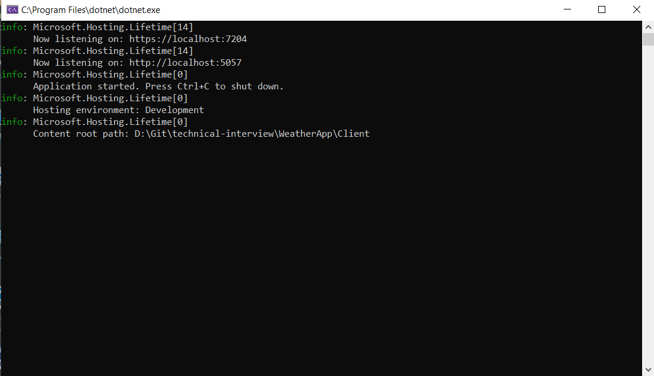

Found the Submit Button in the Index.razor file.

It appears to be in “loading” status by default.

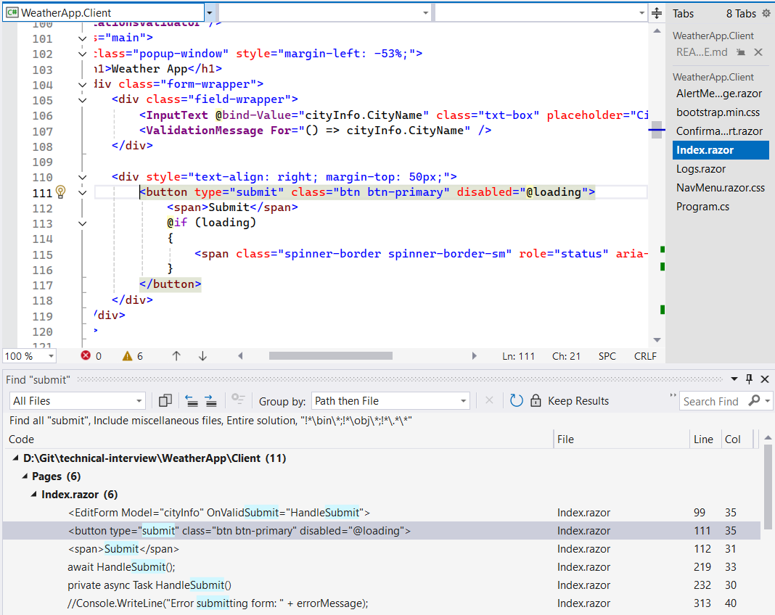

Stopped “spinning” “loading” by altering code, albeit by “brute force” and may not be the most elegant solution.

Tried New York, tried changing city to Baltimore and clicking Submit doesn’t yield any result, nor is anything on the log page populated.

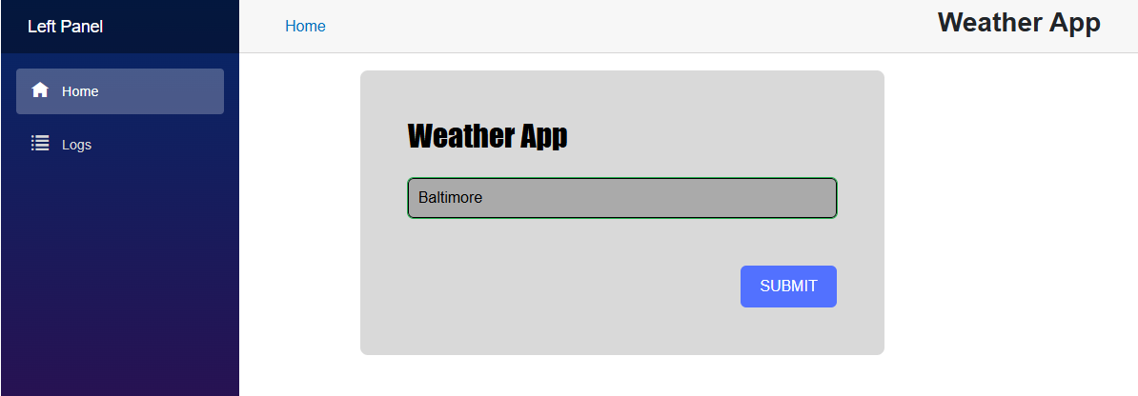

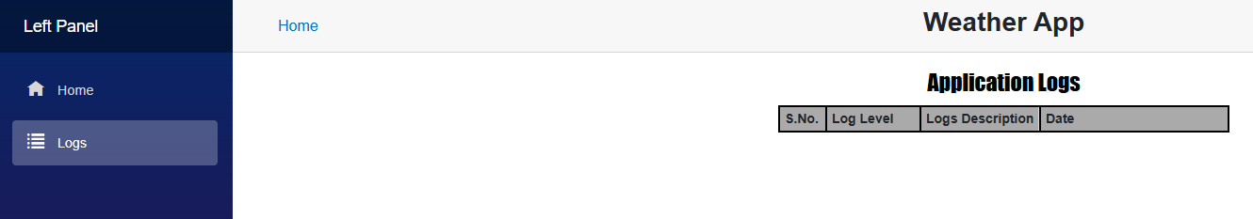

Interesting note.

I use a VPN and was connected to a server in New York and when I turned the VPN off the landing page/index page came up as Baltimore.

Admittedly, I have not used Bootstrap or Razor/Blazor. So, these are things I’d have to become more familiar with.